**Title**: Space themed Points Game

**Name**: Ian Berigan

**Date** : 3rd December 2017

**Student Number** : 17428946

**Introduction:**

The aim of this project was to create a working project that ran in processing and was of the studnets own design. I decided that I would choose to make a game in the processing 3 ide, I decided to make a game in processing as like many others my choice to study computer science was heacily influenced by my fondness for computer games and computer graphics.The libraries that are used in my project are P2D and Spirite.Spirite and P2D allowed for the importing and use of images which had been found the on the internet to be included in the project with 3 sepreate .png files being used in different ways in the project these libraries where quiet and addition to the graphics used in the project.

**SPECIFICATION:**

The program that I decided to write was a game, the objective of the game is to get as many points as you can without losing the game. The game is set to have three lives by default but if someone wnated to modify this code to have more lifes they easily could. The objective is to get your alien in his little spaceship form one side of the screen to the other , points are obtained by having the alien move between the bars which go up and down the screen one coloured blue and the other coloured red , the longer that you hold over the bar the more points you will accumilate but it is benafisile to the player to swicth between the bars as there are little blackholes which are bouncing around the screen which will block the players view which could lead to them losing a life .A player will lose a life when they go beyond the bars on each side of the screen and also if they are to go off the bottom of the screen , they have three lives each time one of these moves i have described happens a life is lost when you reach zero lives the game exists and your score is printed at the bootom of the processing window.This program will run on all machines as long as they have the libraries and processing 3 installed, the speed of the machine is the only real factor as some slower or older machines may have trouble with the images moving around the screen as it may cause the computer and game to run slower.

**OVERVIEW OF CODE:**

The first comments on the code show the image names that have been imported to use in the code,next is all the variables which have been declared outside of the setup() and draw() functions eg variables to keep track of score.Next is the setup() function this is where the size of the screen has been decided and the images have physically been loaded into the code and an instance for the blackholes has been added.Next comes the draw() fucnciton this is where the meat of the code is,in this area you will find all of the objects that have been drawen into the program such as the rectangle paddles that are going up and down the side of teh screen.Also in draw is the code to make the blackholes rebound and bounce of each other when the program is run and below this is the if statements that control when the score an lives increase and decrease and when the game is endded and the screen exists.Outside of the draw fucntion is more code that is related to the collision of the blackholes followed by the blackhole class thsi is where the blackholes that are displayed on the screen are created and the code for there collisons is held.

**TESTING:**

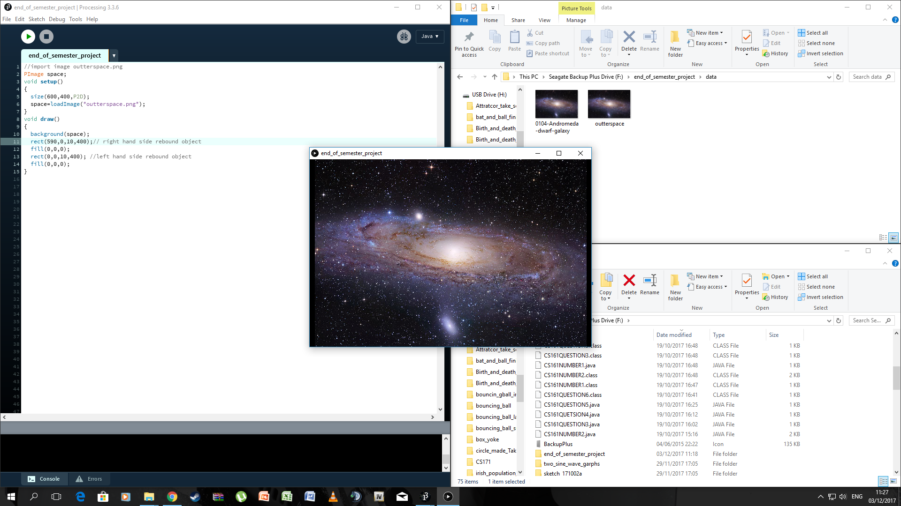

**Figure 1 shows the background image that i had added running in the program as I began the project.**

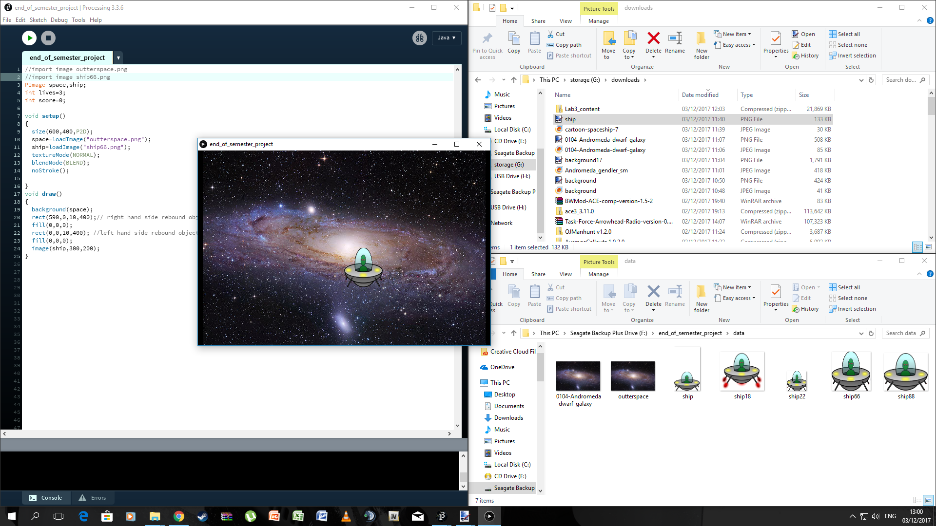

**Figure 2 above shows the alien and spaceship neing added into the code. The spaceship is controlled by the mosue moving on the X and Y axis.**

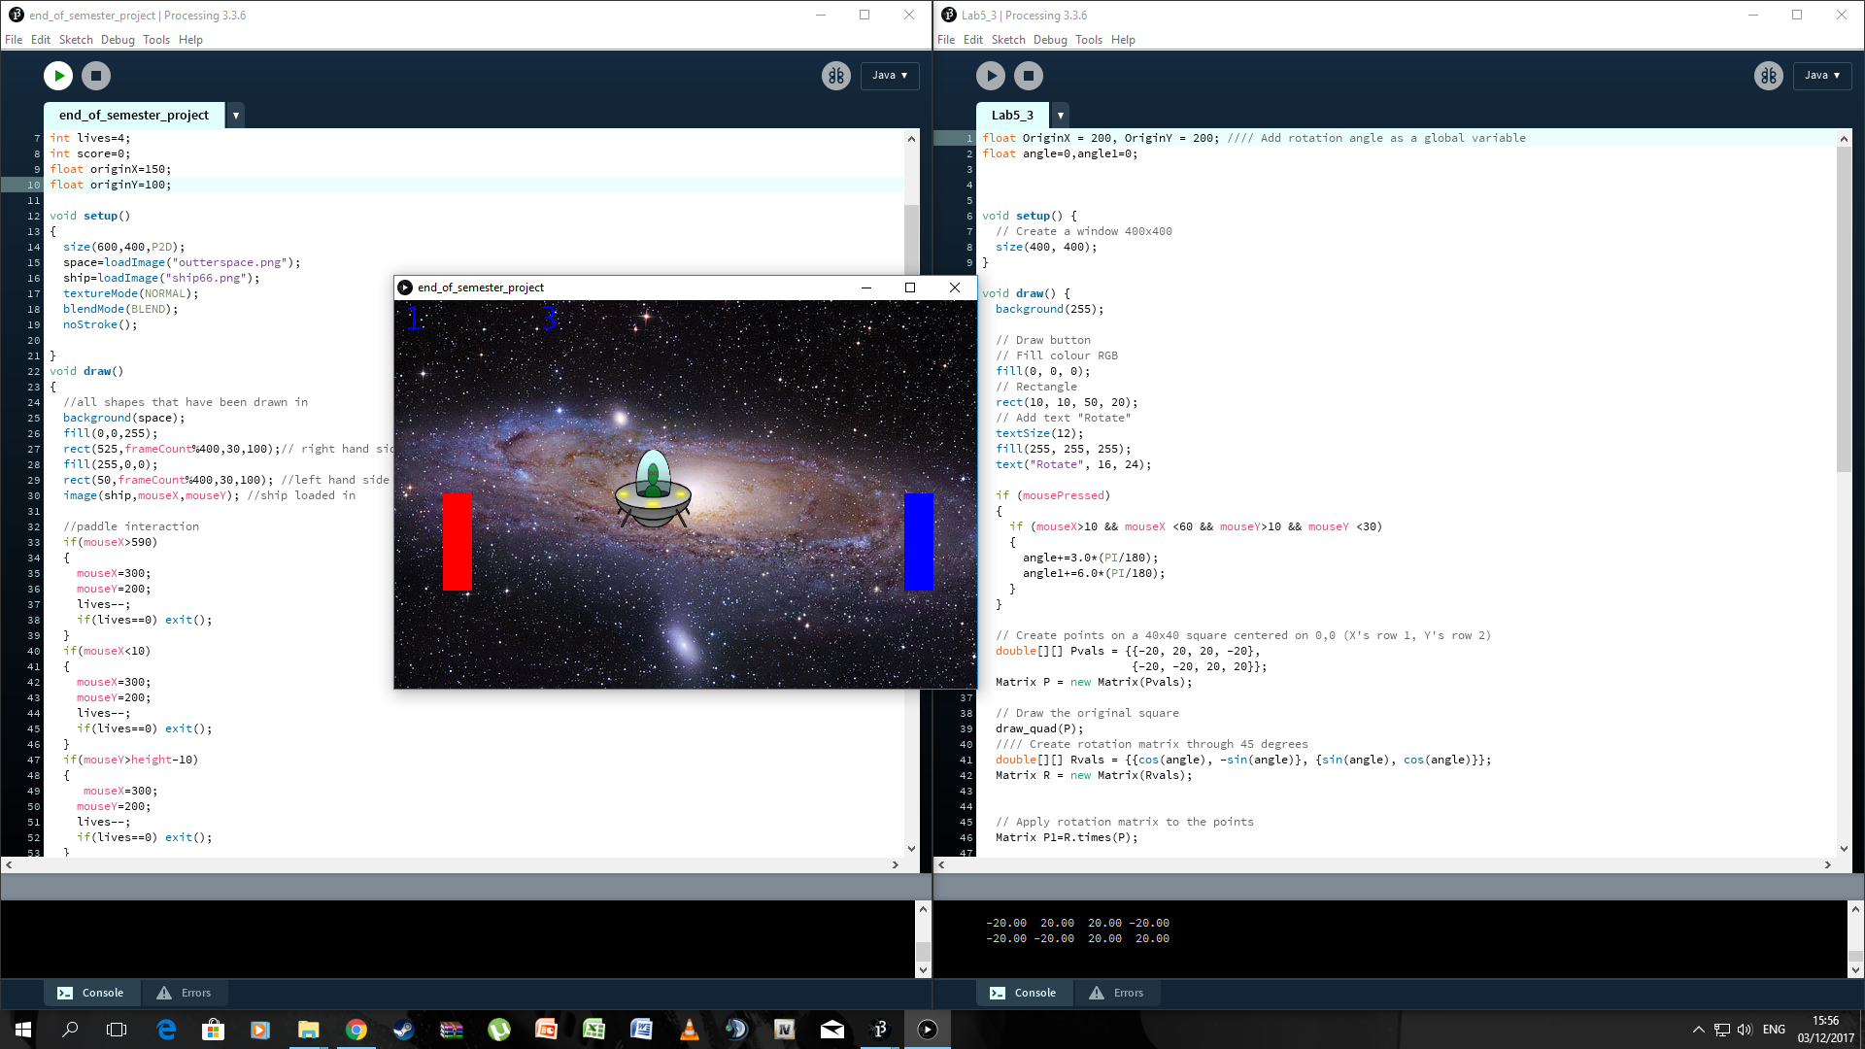

**Figure 3 shows the paddles being added to the code , teh paddles allow for the score to increase when the spaceship is on them, or decrease th eplayers lives when the player passes them or hits the bottom of the screen.I found that sometimes when running the game the player would not have points register this is deduced was down to the use of spirite and the blending of the textures , soemtimes the player would have to find the sweetspot to score points.Also sometimes if the mouse was moved a tiny bit to quickly or was at the edge of the screen at the start of the gamethe player would loose a life but these where very rare occurances.**

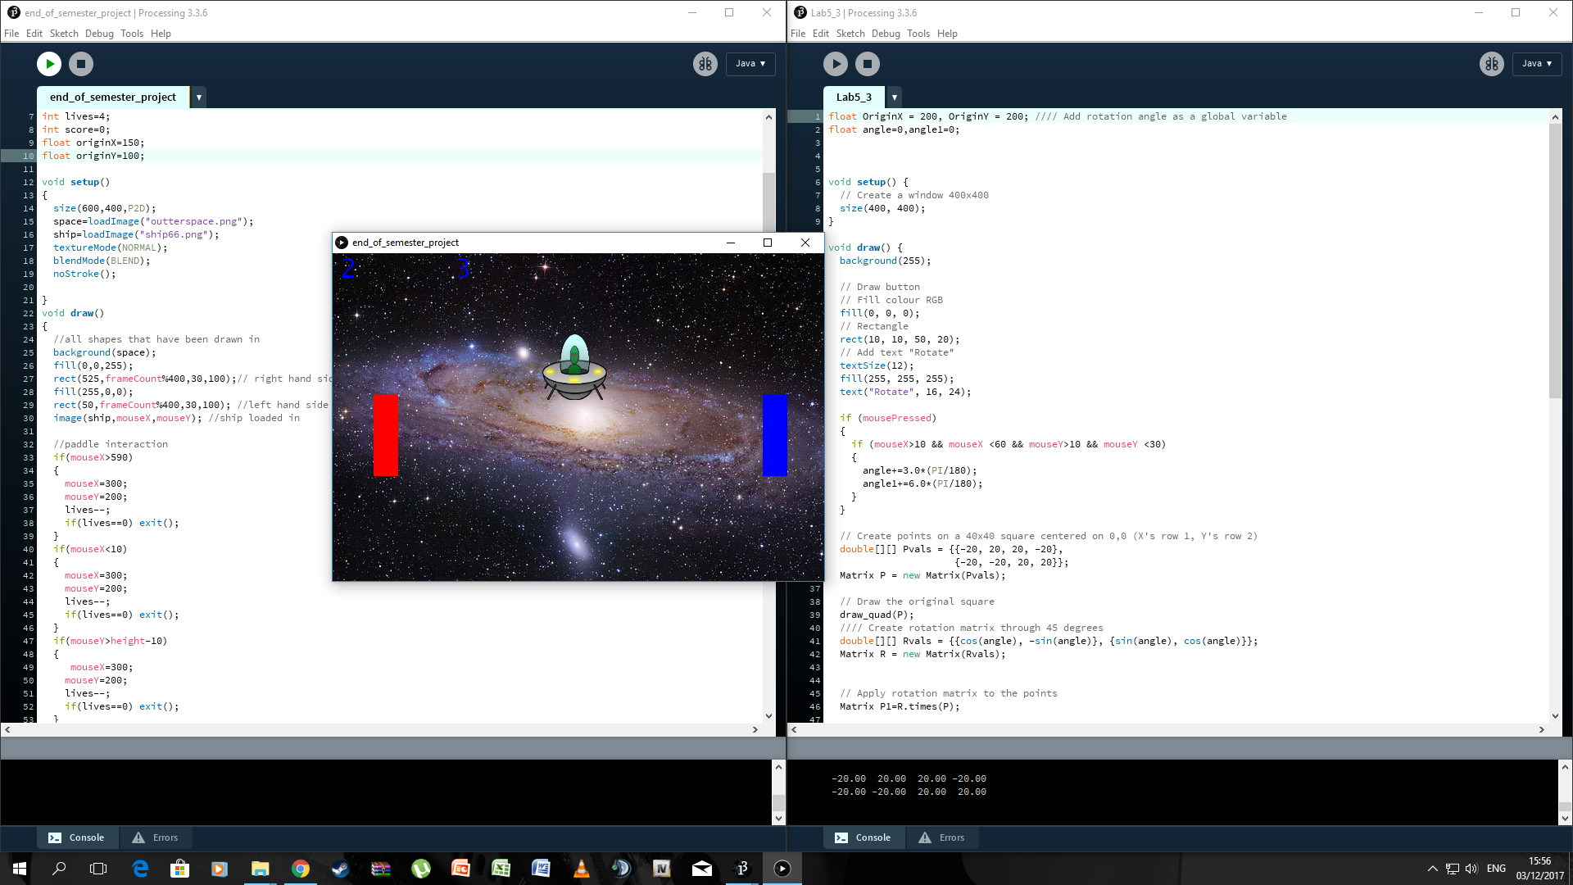

**Figure 4 above shows a continuation of the previous screenshot, in this screenshot the score has increased in the top left hand corner.**

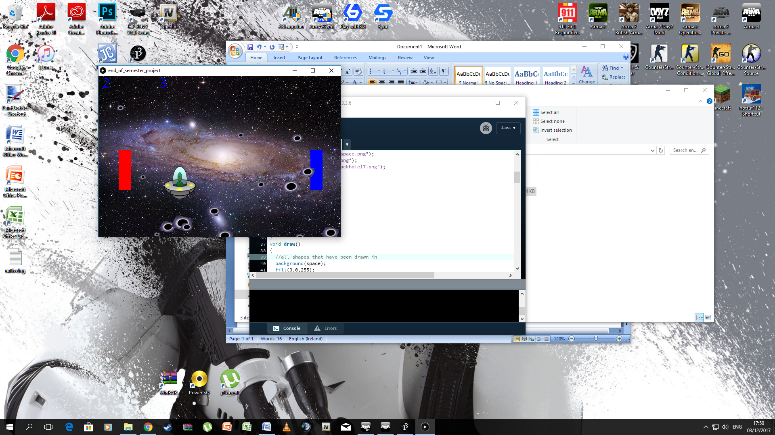

**Figure 5 shows the final game running on the desktop with the blackholes included which fly around teh screen in an attempt to obstruct the players view.**

**conclusion:**

In this project I have achieved a working simple game that uses libraries in processing to allow the player to play as a cartoon alien and try and score as many points a sthey can by going from one paddle on one side of the screen to the paddle on the other before they loose all of their lives.In the future work could be done to add a timer for instance where the player has a certain amount of time to get from one side of the screen to another will still trying to maximise the point sthey obtain , also it could be added that if the player was to go over a blackhole that they would loose points or would even loose a life which would add a different dynamic to the game instead of the blackholes being there to block the player.

**REFERNECES:**

The images that i used in my code where found by the following methods :

background = google search outter space and i the went to google images and I used this photo from<https://images.csmonitor.com/csm/2013/01/0104-Andromeda-dwarf-galaxy.jpg?alias=standard_600x400>

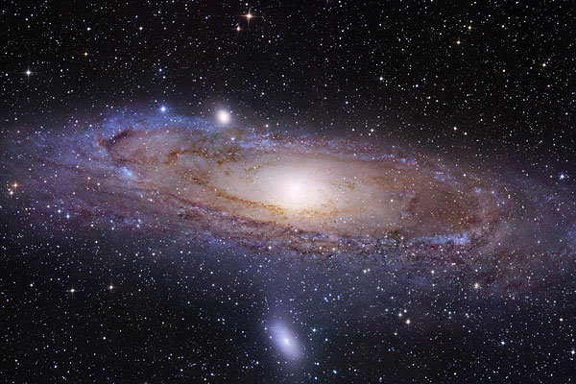 **BACKGROUND IMAGE**

spaceship and alien = google search for space ship 2d cartoon and I used this photo from<http://www.how-to-draw-funny-cartoons.com/image-files/cartoon-spaceship-7.jpg>**SPACESHIP AND ALIEN**

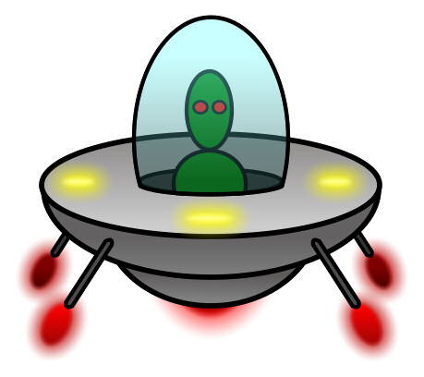

Blackhole = google search for blackholes and I used this photo<https://wi-images.condecdn.net/image/6DoWNVJlrWM/crop/405>

